**Lab II**

**Developing Web Client application using JsFiddle**

*Sailaja Pedaprolu, 16157493*

An application namely, ‘Travel Router’ has been developed. The application takes two inputs from the user – source and destination. Then based on the locations, the route is displayed on the map.

The following screenshots show the working of the map:

Initially, the city names, austin and newyork are entered in the departing city and destination city names text fields.

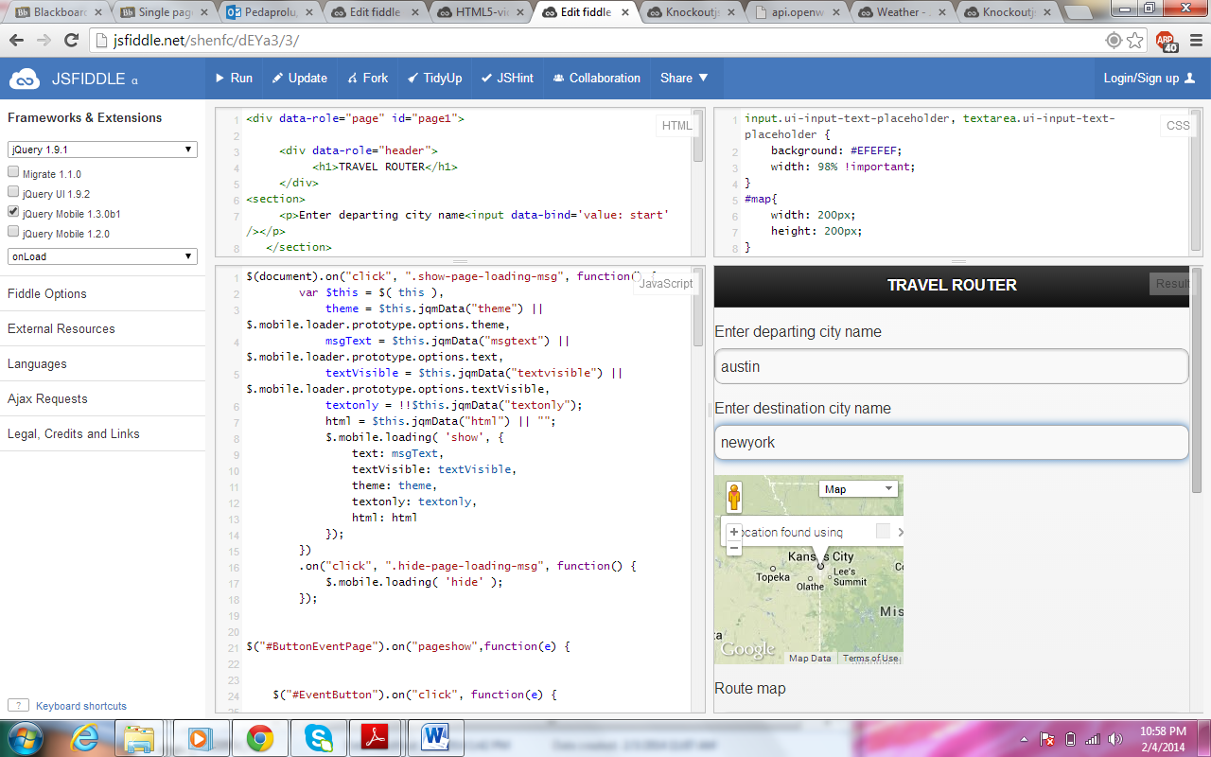

Next, when “show path” button is clicked, the map displaying the connected route appears.

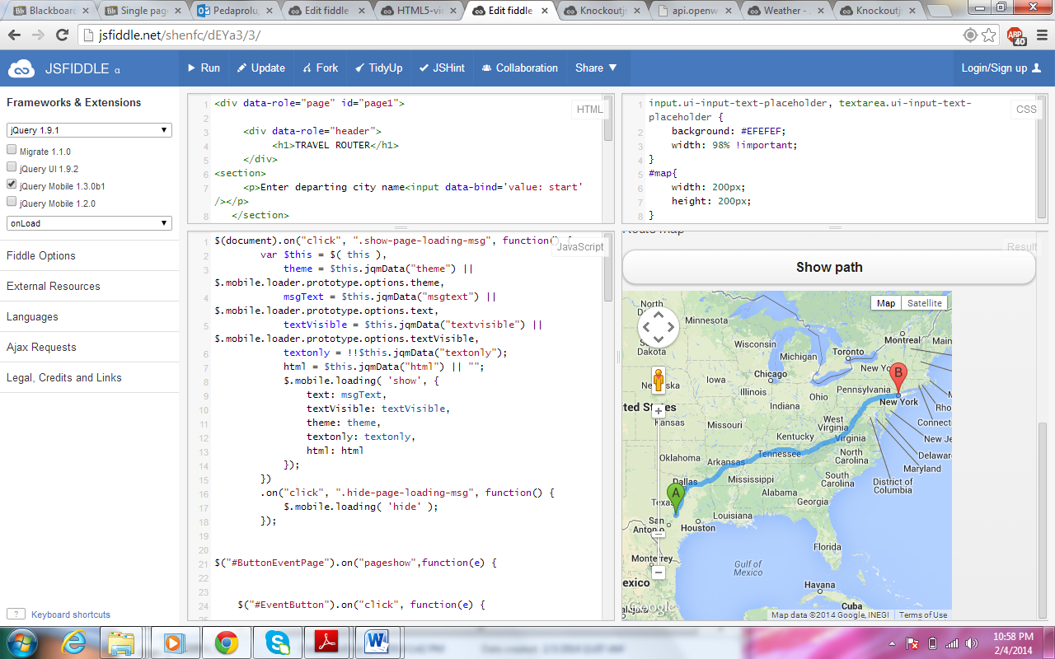

The same working is repeated by changing the city names to Vegas and Ohio

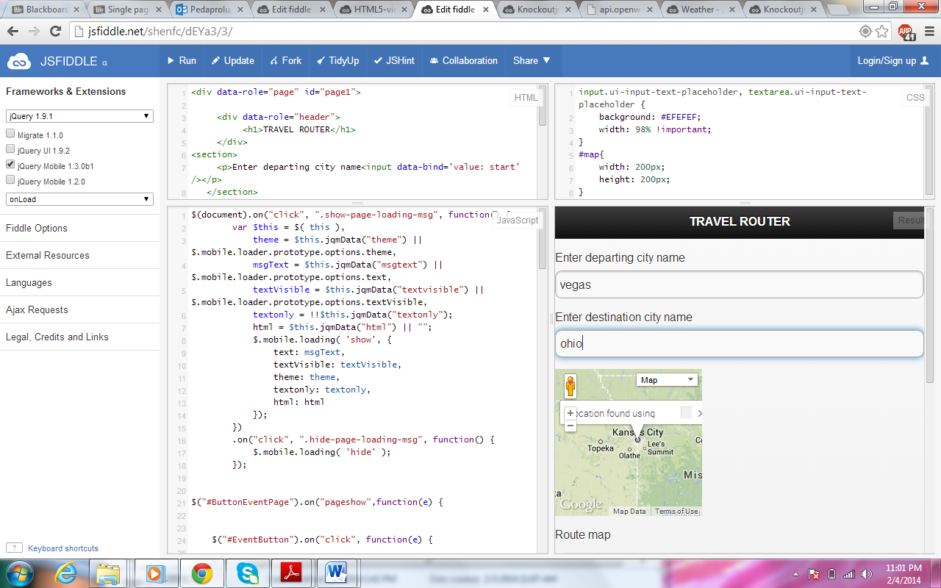

The corresponding route is displayed.

